# Modelling Notes

## Outliner

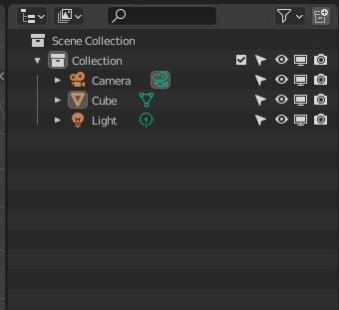

 Enable the object selection – that means allowing the object to be selected or not. Useful for dense scenes.

 Enable/Disable Global visibility. That means it can’t be seen from any viewport. Not too sure how it affects everything.

 Disable/Enable the visibility of the object when rendering.

## Lighting

### 3-point light system

Create a collection called “Lighting Rig”. This will contain your 3 light points: **Light Key**, **Light Fill** and **Light Back**. Note that **Light Fill** and **Back** has less power than **Light Key**.

Cntrl + P is parenting objects. Make sure the intended parent is active selected (Shift click on object)

## Rendering

### Eevee

Quick Rendering but requires more inputs and values. Though the big plus side is that it is really really fast.

### Cycles

Real Time rendering but takes longer to render. Might have some grainy bits. That being said, it does not need any particular input like “adding bloom or ambient occlusion”

## Vertices, Faces and Edges

### How to solve vertices that are on top of each other?

Wireframe mode - select the vertices that are merged on via a selection box.

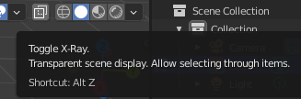

You can also toggle x-ray to select them. The point of x-ray is to ensure you can get a sense of shape from this.

### Remove doubles

Press F3, then type remove doubles, click mesh: merge by distance

### Quick selections

Pressing L with the cursor over one of the faces of the object will help select all the faces of the object at once. Shift + L will deselect it.

### Complex models:

**How to select loose geometry** (vertices that are not connected to any other vertices but are still considered part of the model).  
  
F3, search for loose geometry, then delete it.

## Materials

### Assigning different materials

Add multiple material slots, add the materials.

Go to Edit mode -> use faces selection (it’s easier that way) -> Assign material via assign button.

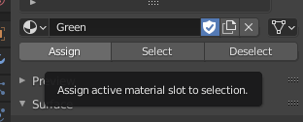

### How to prevent materials with no objects assigned to it from disappearing

Use the Shield icon in edit mode.

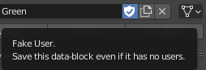

## Normals

### What are normals?

Normals are perpendicular “lines” to an object. For example, if you draw a straight line on paper, the normal to that is a perpendicular line.

In the 3D world, the simplest face is a flat 3D triangle.

Normals are used for Smooth shading and others.

But one thing to be warned about is inside normals, those are hard to figure out as they could make the object show up as invisible when exported.

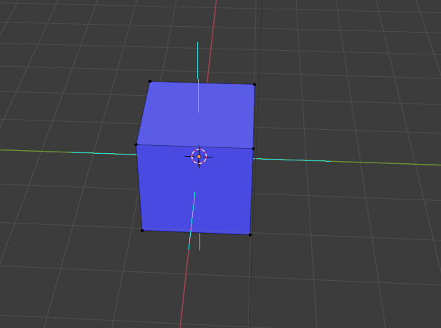Blue Lines = Normals

Blue sides = Outward facing normal

Red Sides = Inward facing normal

### Solutions to solve inward facing normals

Shift + N to recalculate normals (Refer to diagram for assistance) 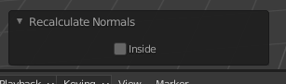

You can choose inside or outside to specify.

Final checklist before export  
- Shift + N all faces so that normals are recalculated

## Insetting

### Insetting issues

NOTE: Do finish your insert before doing other operations.

## Loop Cuts

### What if you want to make two, parallel loop cuts?

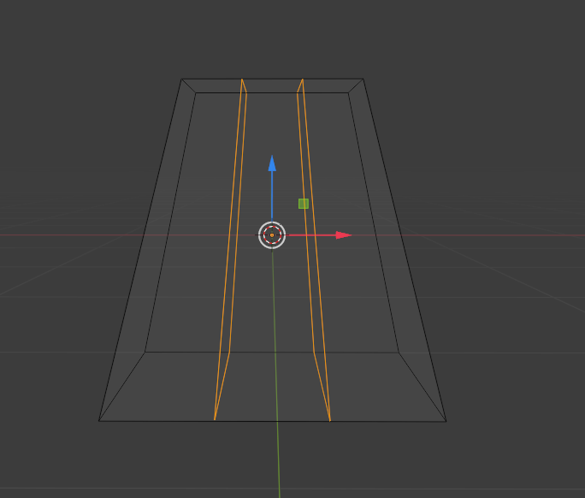

**Solution 1:**

Add one loop cut in the center, then do nothing to it. Add second loop cut off to the side, then bring it up to the first loop cut. Afterwards. Transform it evenly and there you have two separate ones.

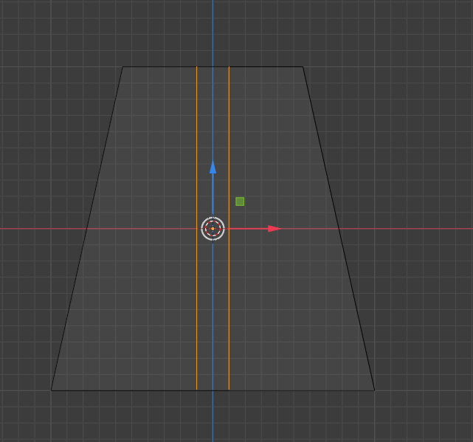

**SHORTCUT**: Left alt and click to click all the loop cuts

## Some warning for self

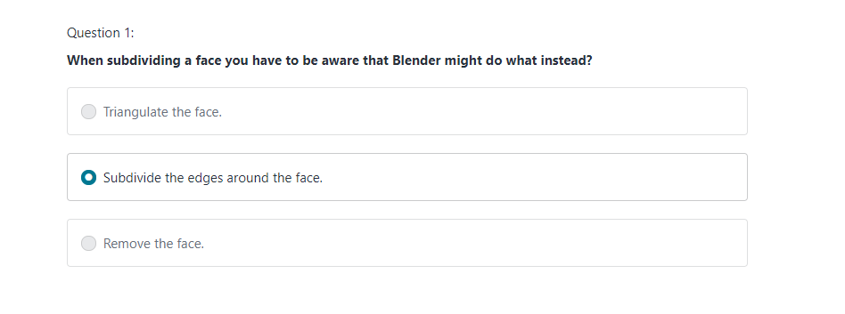

## Modifiers

Modifiers are things that affect the object without the object itself from being affected

### Adding Arrays

Wrench Icon -> Add Modifier -> Under Generate, Array

### Relative Offset vs Constant Offset

**Relative Offset** -> If you need to Stack stuff like stairs

**Constant Offset** -> If you need to fit something within a certain space

Both can be turned on at the same time.

**NOTE**: Cntrl + L to duplicate stuff like modifiers. Object 1 (to be added the duplicated modifier) and Object 2 is selected, with Object 2 as the active selected.

## Joining Mesh Objects

Pretty much Cntrl + J for Mesh Object joining

### Mesh Objects joining warnings

***Warning 1***: The active selected object’s name will be the one that will remain. So if you named your objects *A* and *B*, the active selected object’s name, *A*, will be the name for the joined objects.

***Warning 2***: All modifiers will be lost if and object with modifiers are added. Thus, this is when you’d want to apply them.

## How to flip an object

